# **Difference**

# **Data Insertion**

## **Example-1**

If Element-8 is less than 3, insert the element to its left (or) insert the elements to its right.

Inserting element-3 to 8’s left

Inserting element-10 to 8’s right

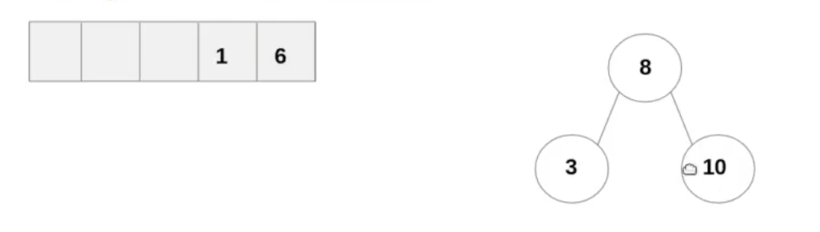

Inserting element-1.  
a) 1<8, so left  
b) 3<8, so left

Similarly for element-6

## **Example-2**

# **Data Search**

# **Reference**

<https://www.youtube.com/playlist?list=PL5tcWHG-UPH112e7AN7C-fwDVPVrt0wpV>